**Title:** Write a smart contract on a test network, for Bank account of a customer for following operations: **Deposit money Withdraw Money Show balance**.

**Code:**

**// SPDX-License-Identifier: MIT**

**pragma solidity >=0.7.0 <0.9.0;**

**contract SimpleBank {**

**struct client_account {**

**int client_id;**

**address client_address;**

**uint client_balance_in_ether;**

**}**

**client_account[] clients;**

**int clientCounter;**

**address payable manager;**

**modifier onlyManager() {**

**require(msg.sender == manager, "Only manager can call this!");**

**_;**

**}**

**modifier onlyClients() {**

**bool isclient = false;**

**for (uint i = 0; i < clients.length; i++) {**

**if (clients[i].client_address == msg.sender) {**

**isclient = true;**

**break;**

**}**

**}**

**require(isclient, "Only clients can call this!");**

**_;**

**}**

**constructor() {**

**clientCounter = 0;**

**}**

**receive() external payable {}**

**function setManager(address managerAddress) public returns (string memory) {**

**manager = payable(managerAddress);**

**return "";**

**}**

**function joinAsClient() public payable returns (string memory) {**

**clients.push(client_account(clientCounter++, msg.sender, address(msg.sender).balance));**

**return "";**

**}**

**function deposit() public payable onlyClients {**

**payable(address(this)).transfer(msg.value);**

**}**

**function withdraw(uint amount) public payable onlyClients {**

**payable(msg.sender).transfer(amount * 1 ether);**

**}**

**function sendInterest() public payable onlyManager {**

**for (uint i = 0; i < clients.length; i++) {**

**address initialAddress = clients[i].client_address;**

**payable(initialAddress).transfer(1 ether);**

**}**

**}**

**function getContractBalance() public view returns (uint) {**

**return address(this).balance;**

**}**

**OUTPUT**

**}**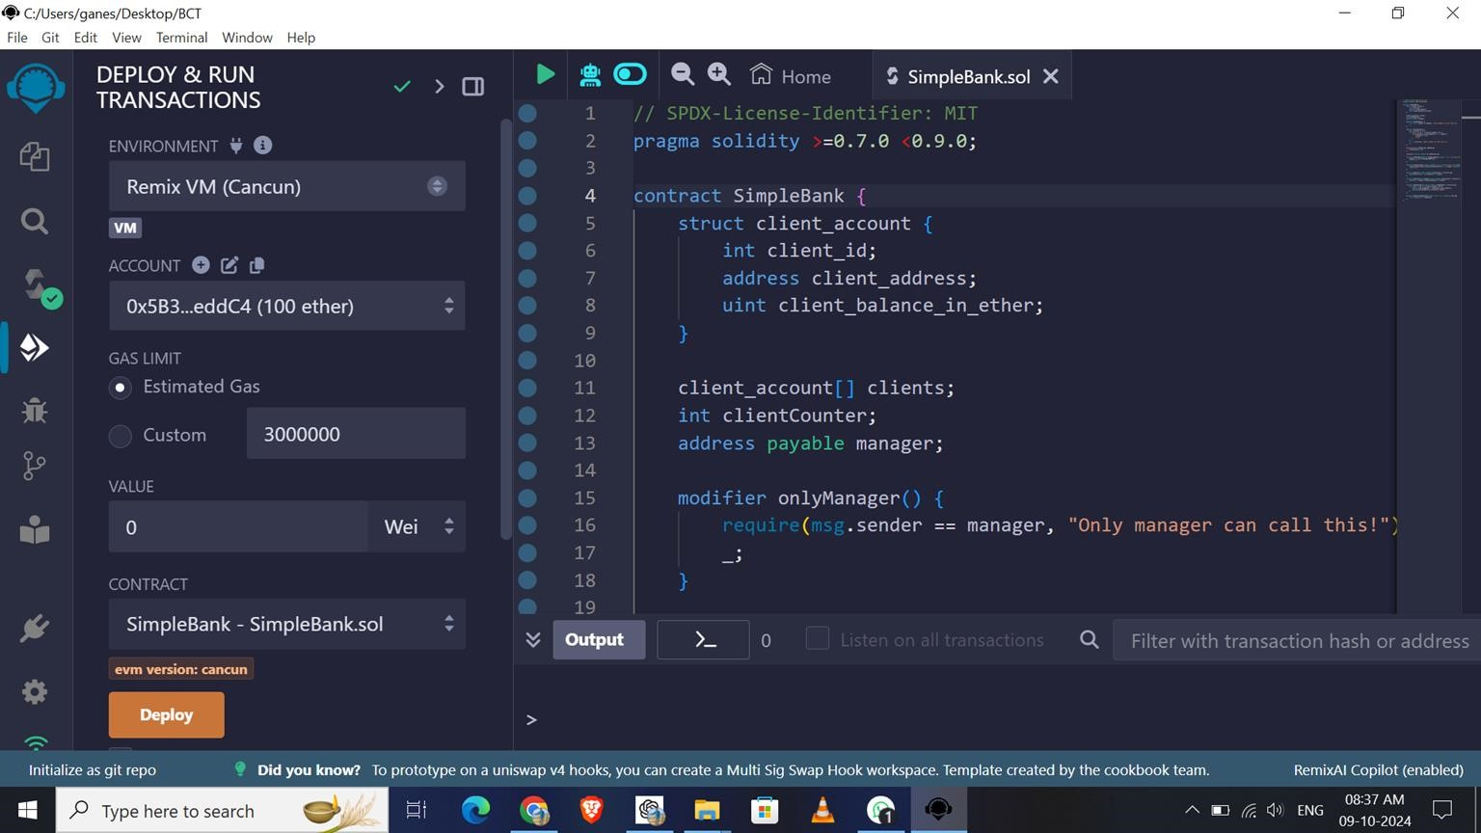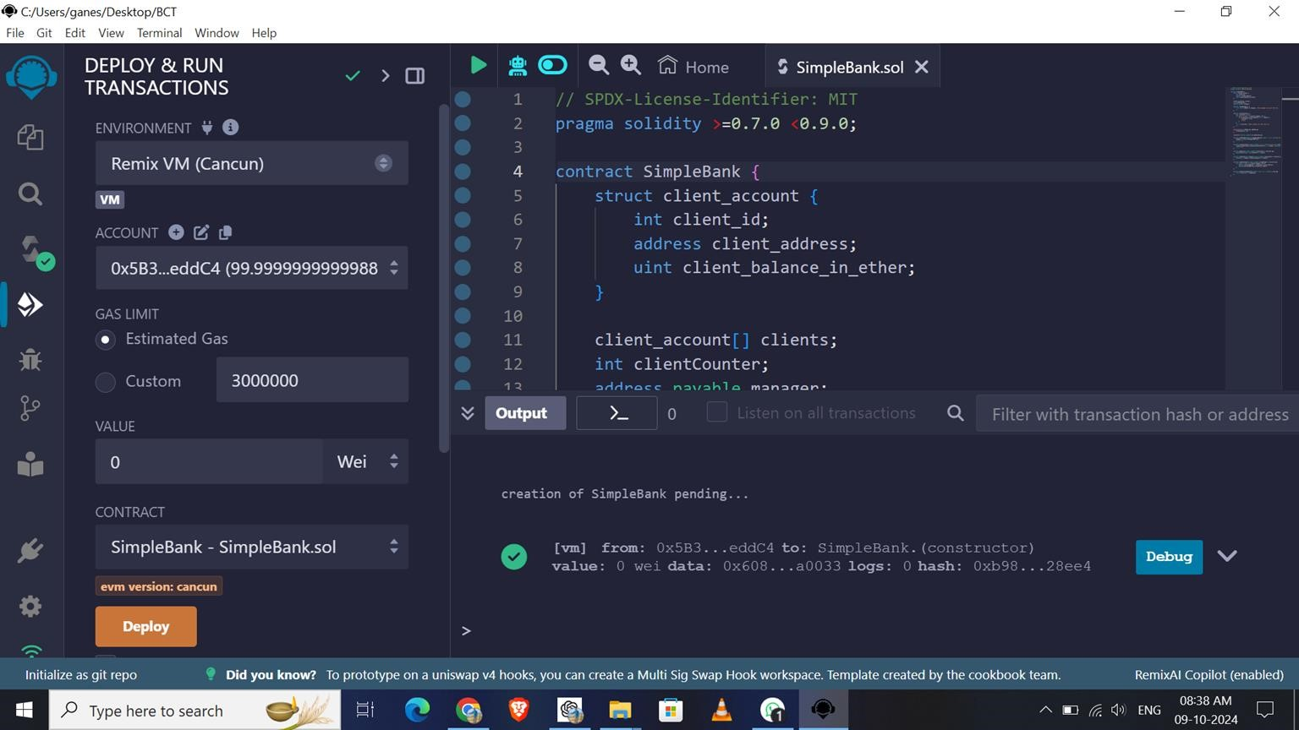

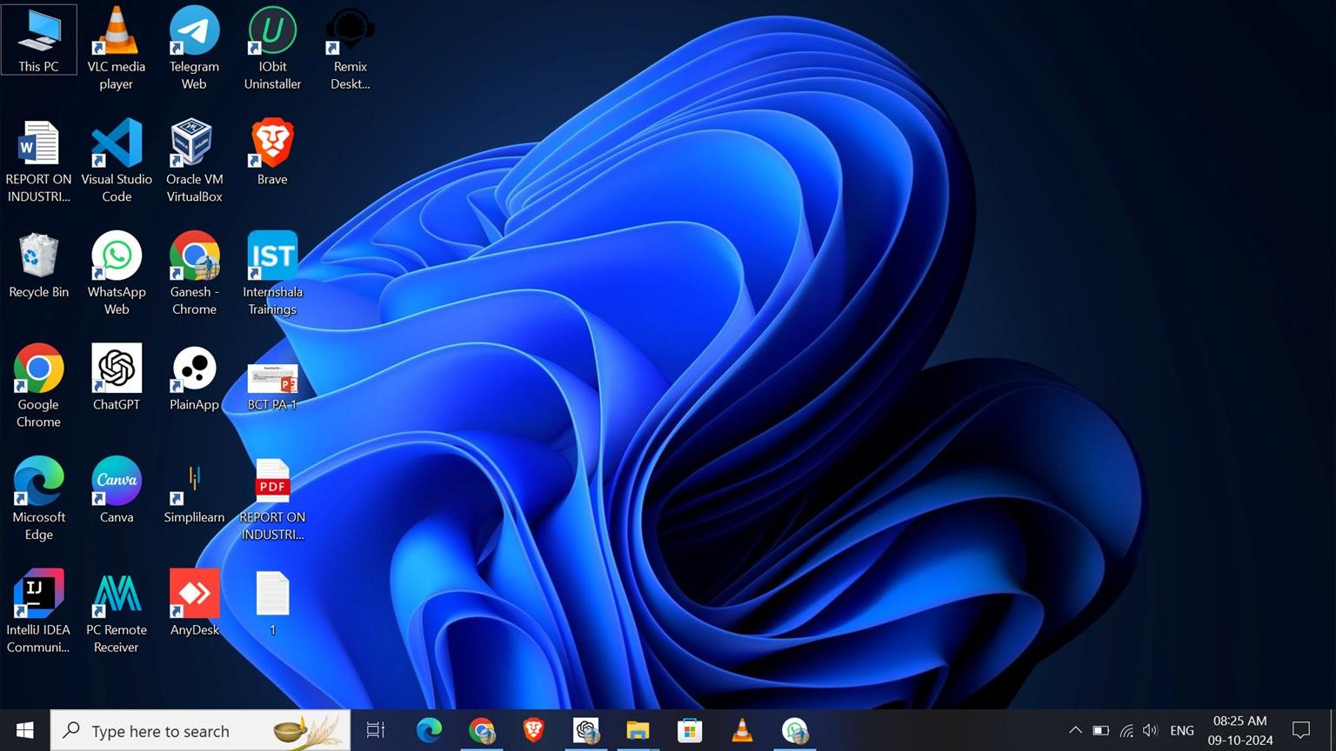

Open Remix IDE

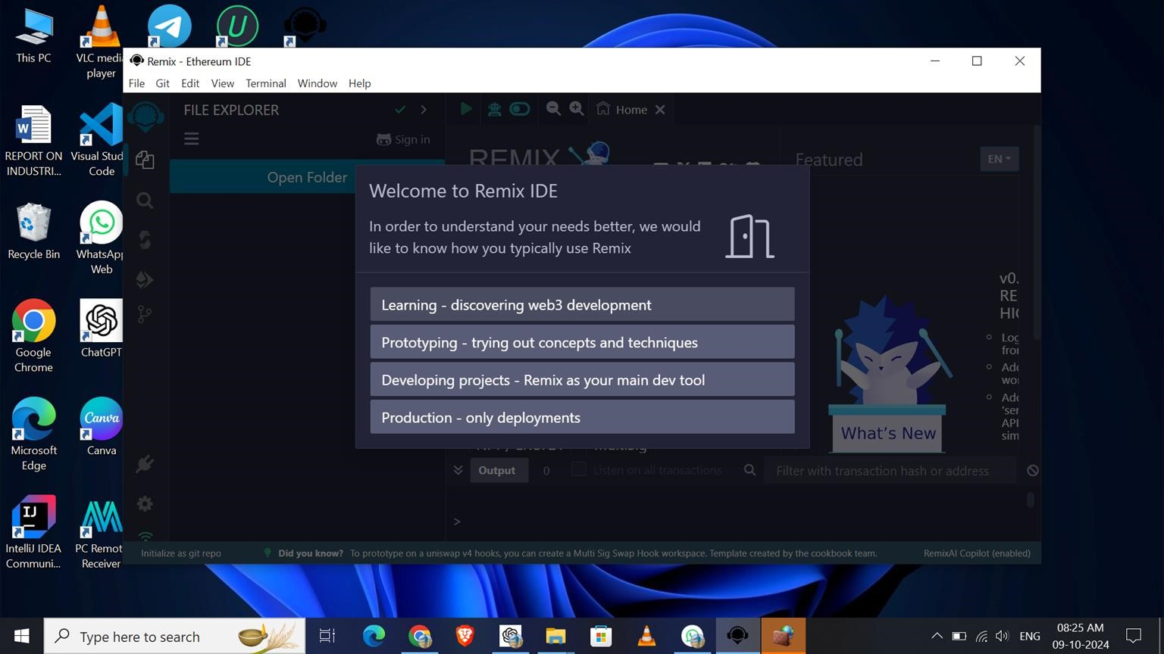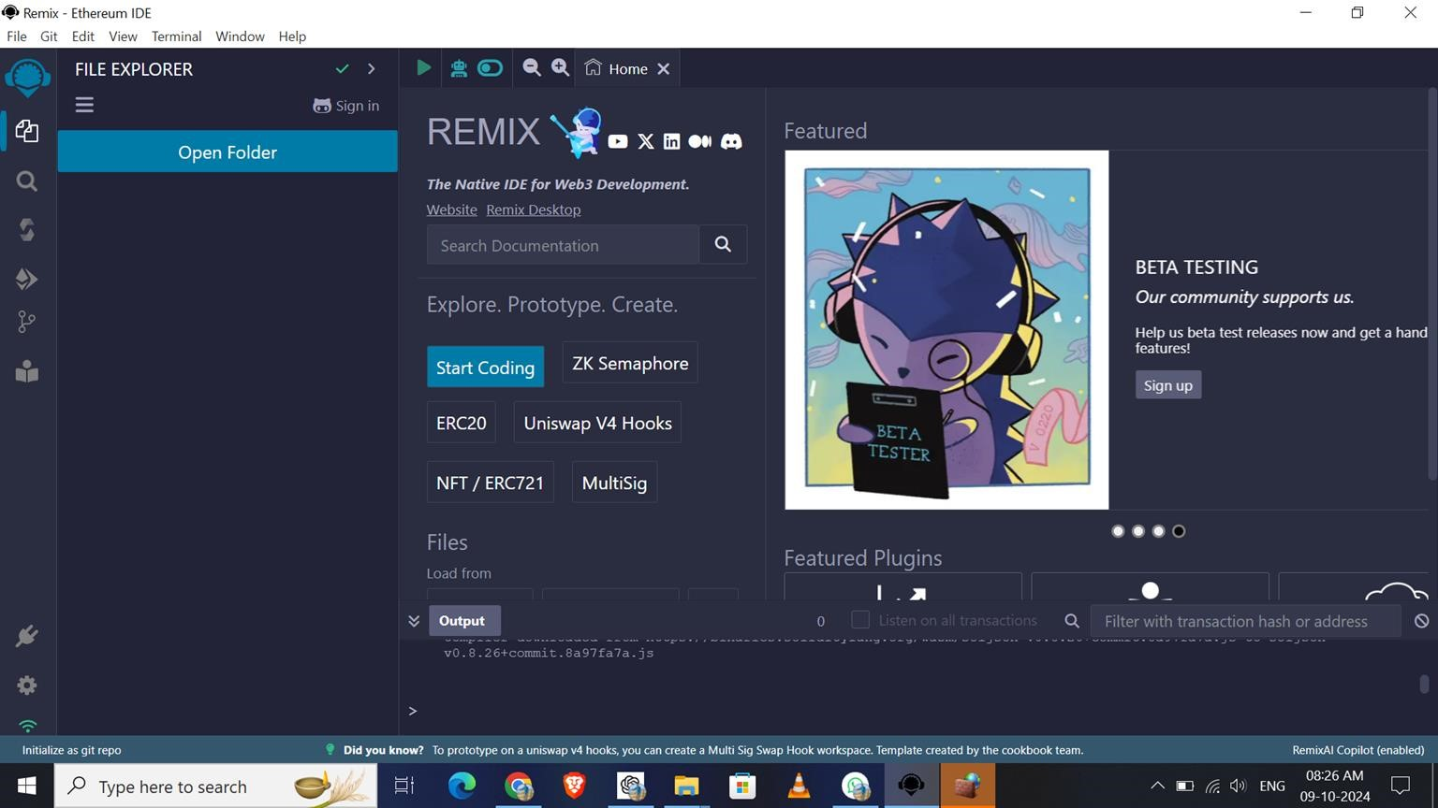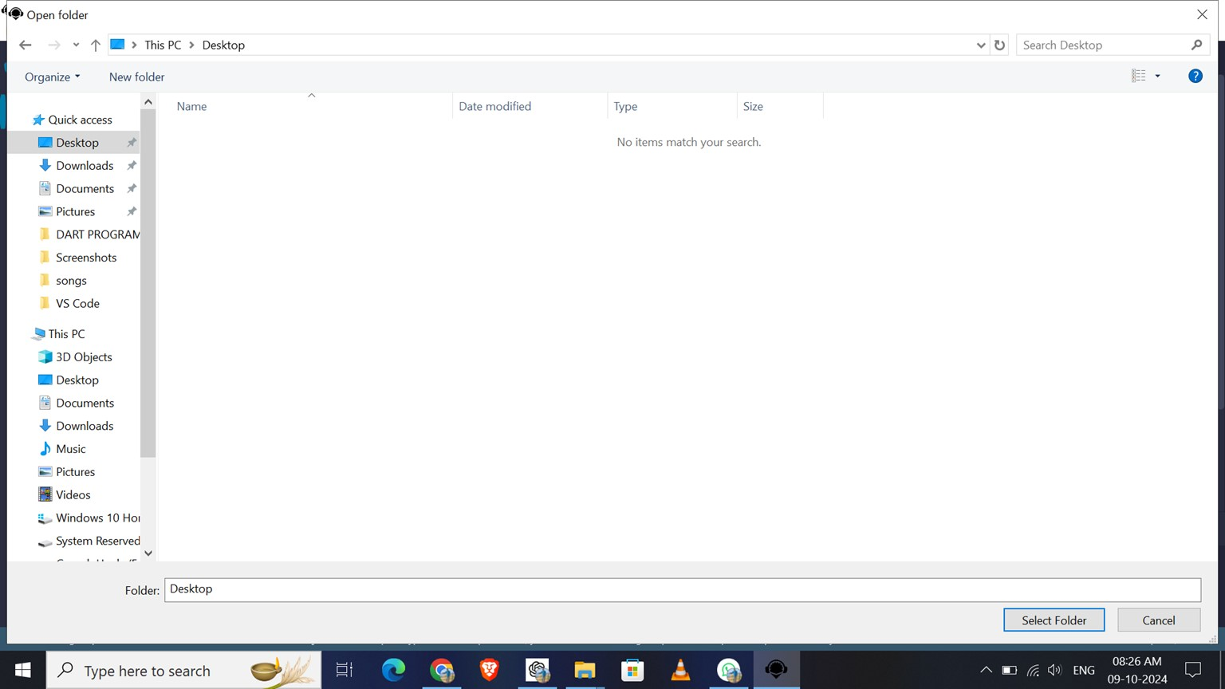

Choose any Location

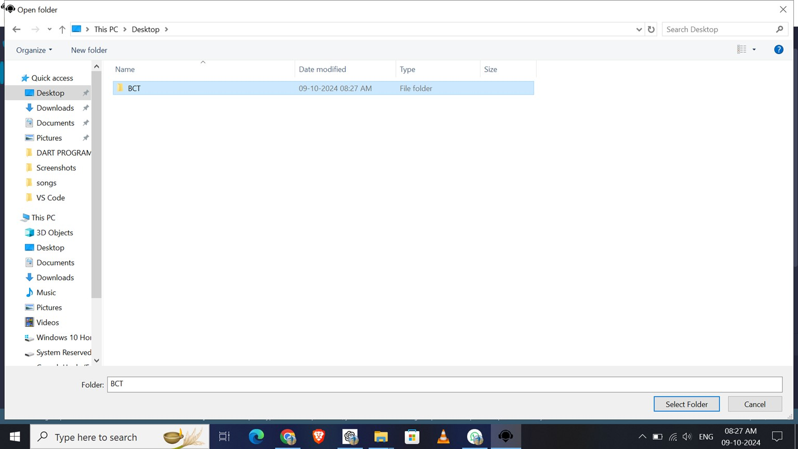

Create New Folder & rename it

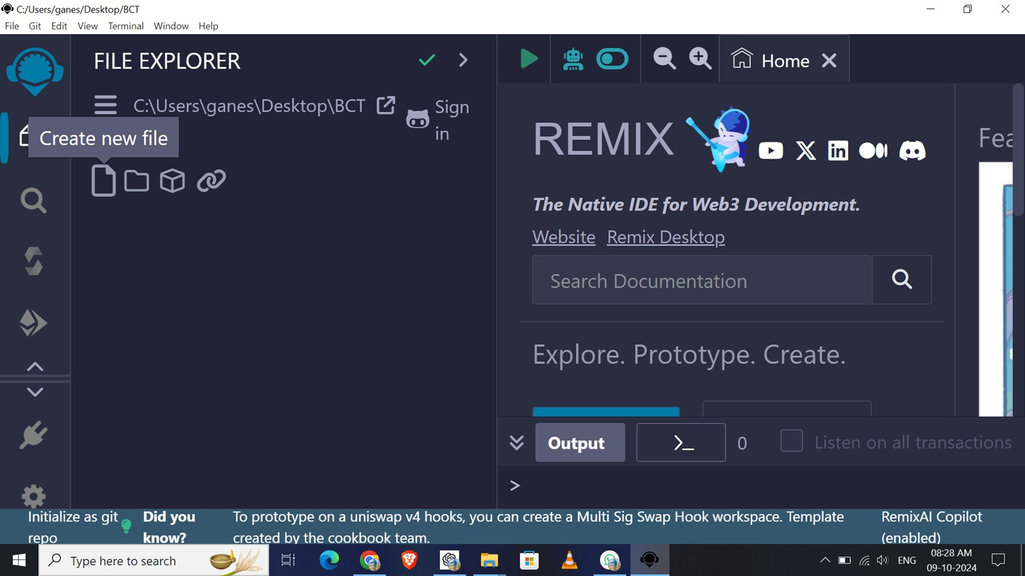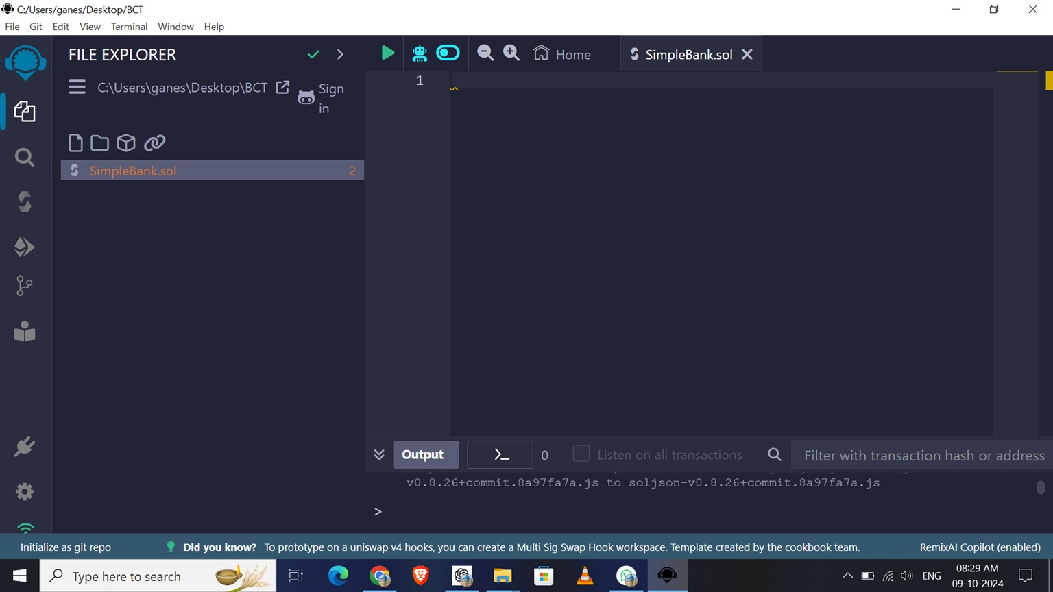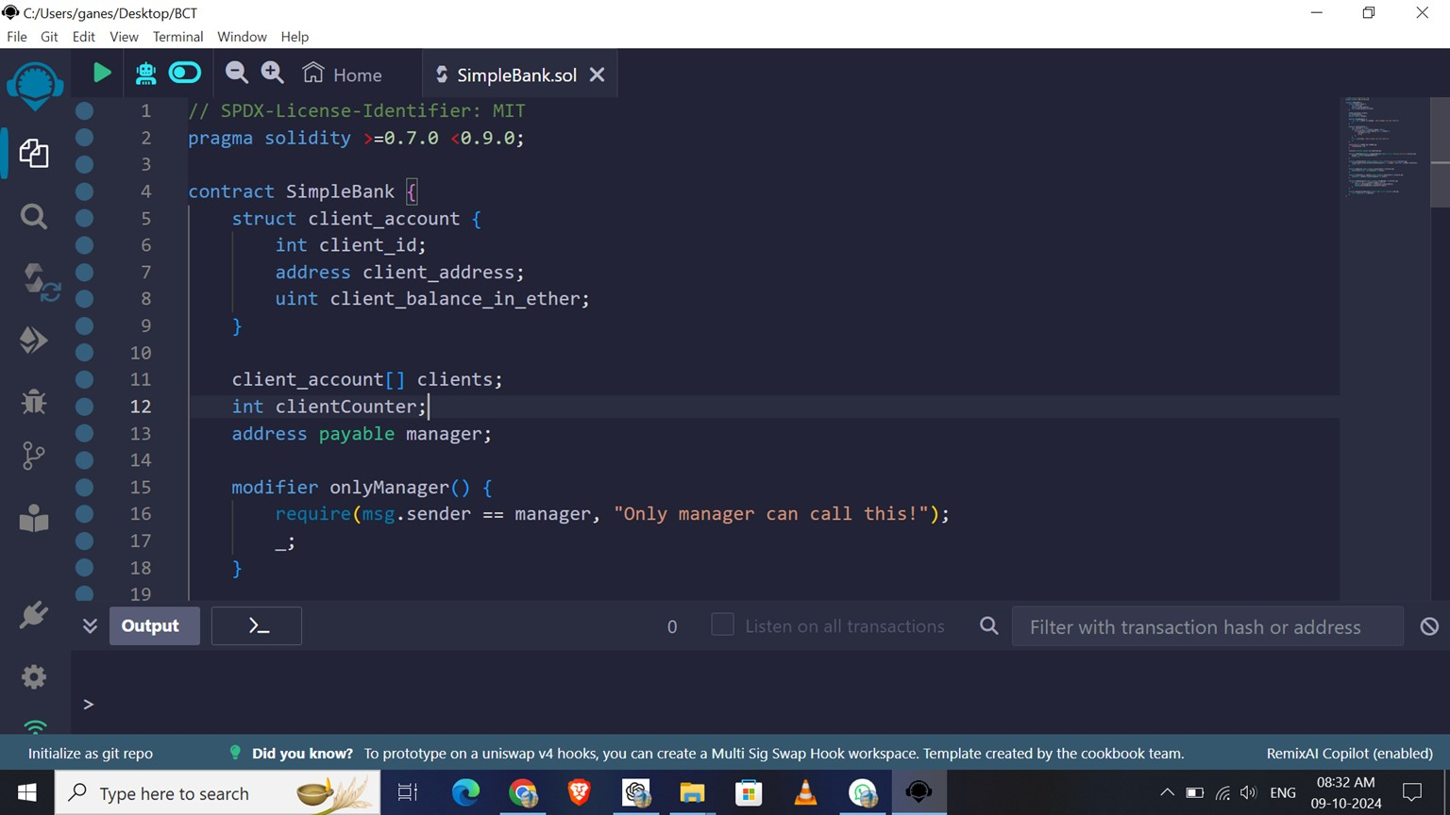

Write a Code Here

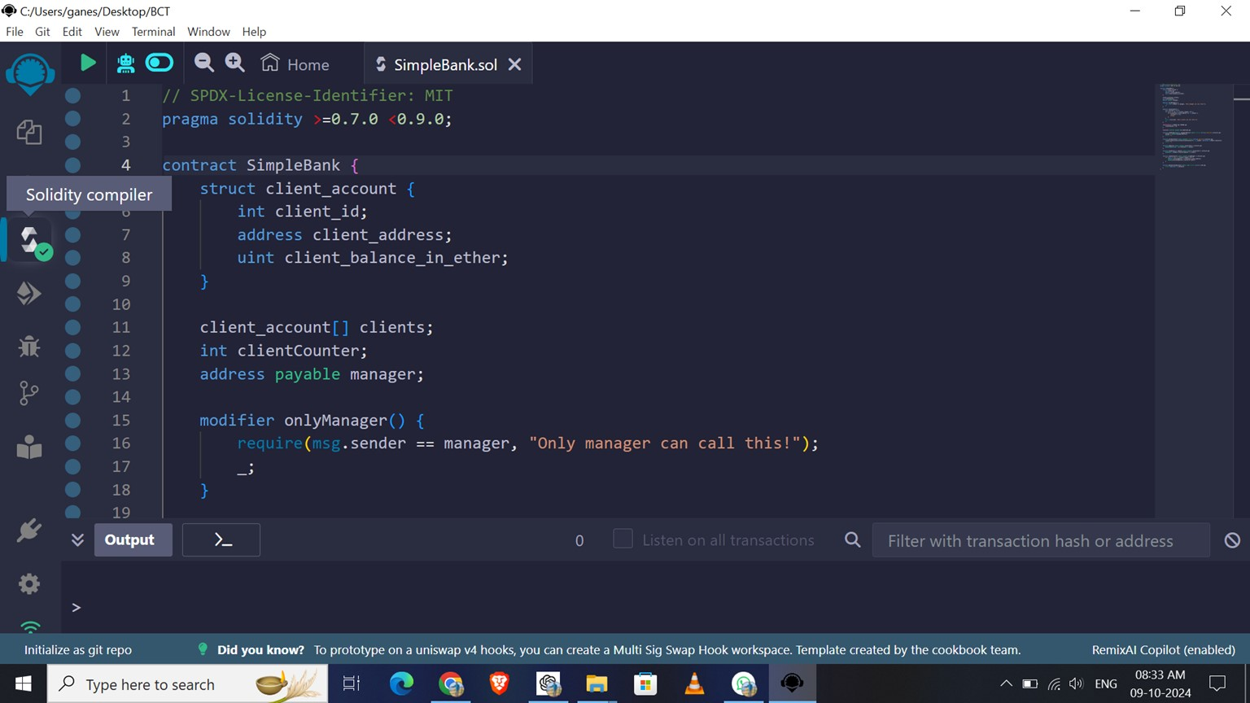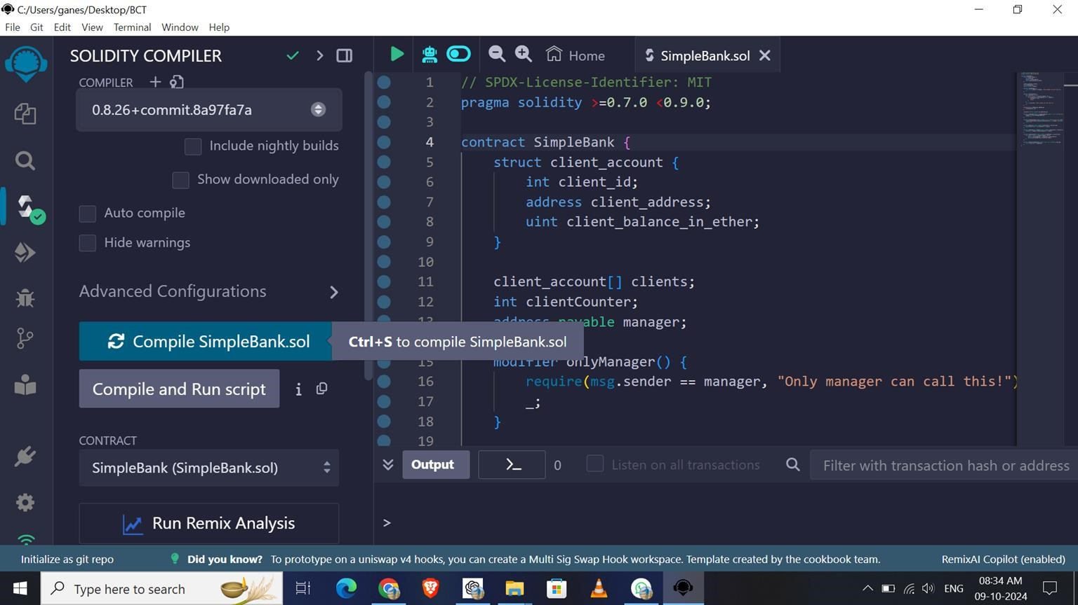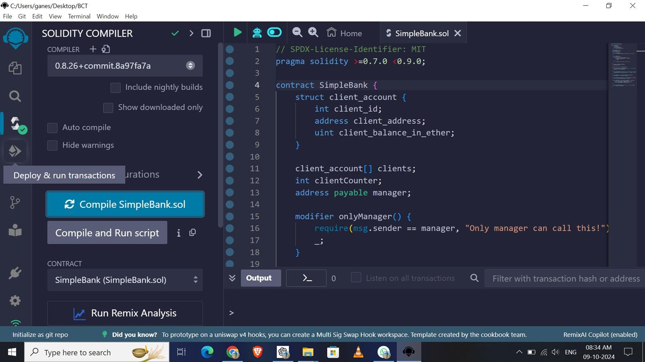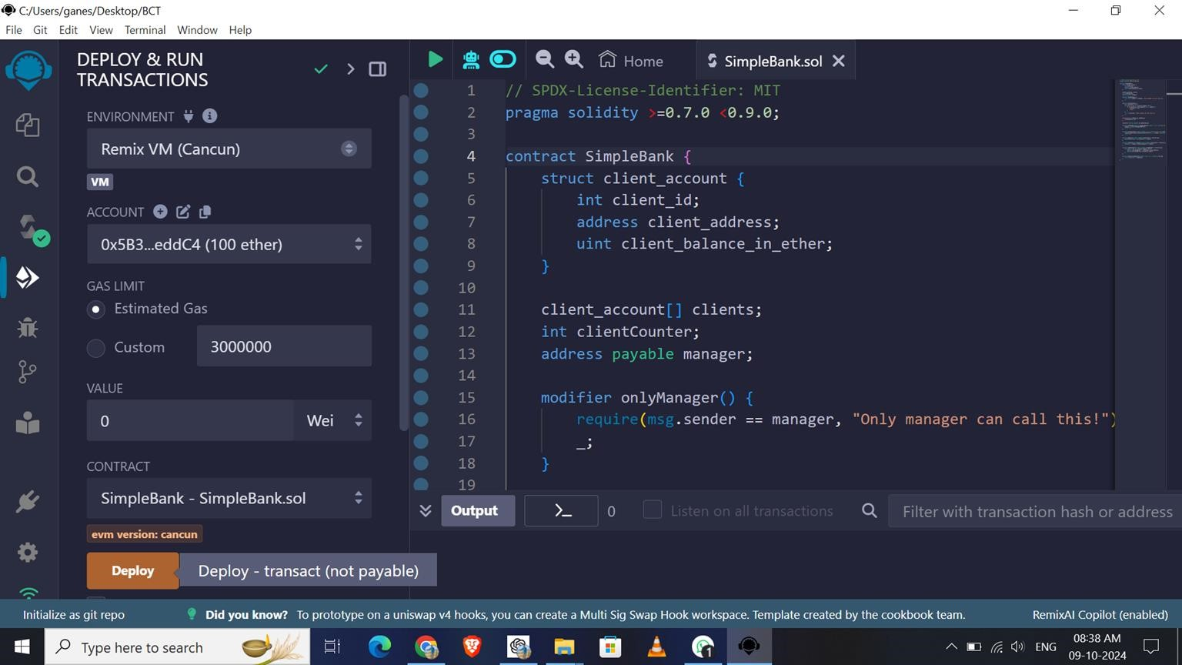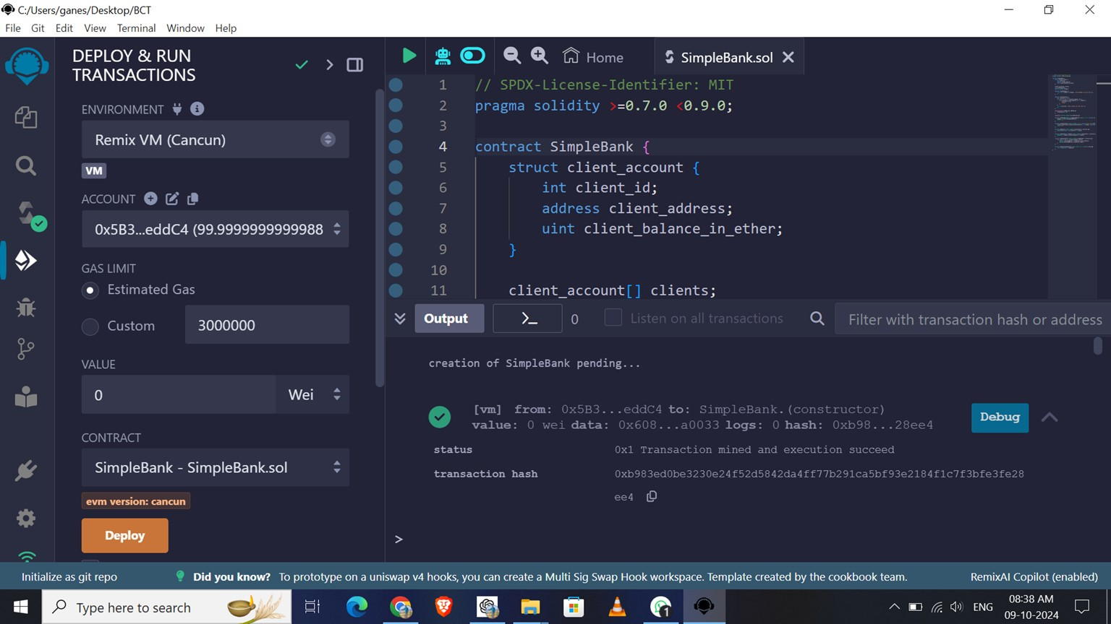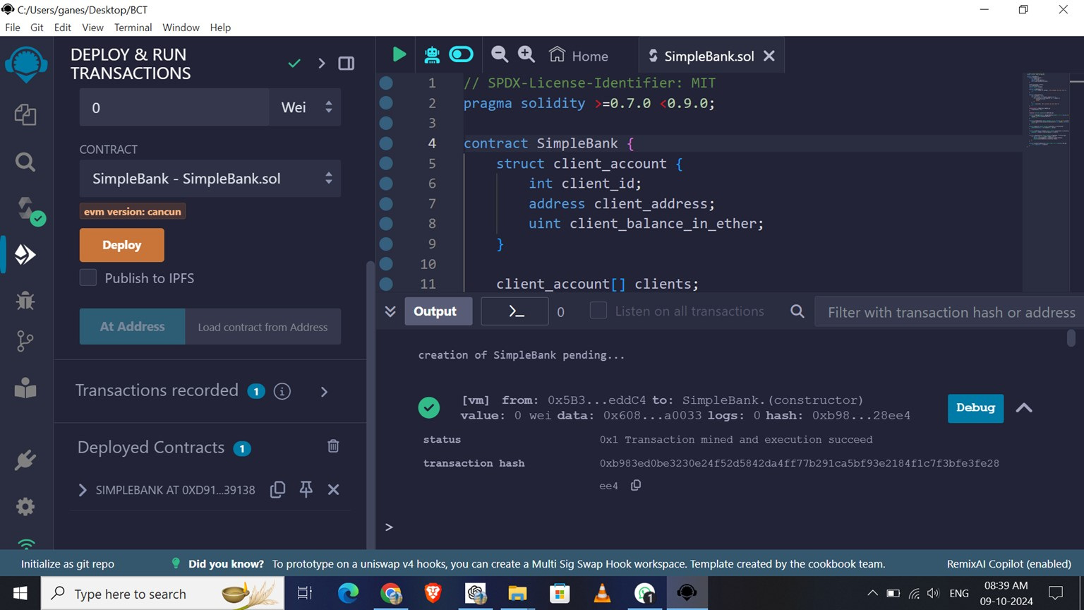

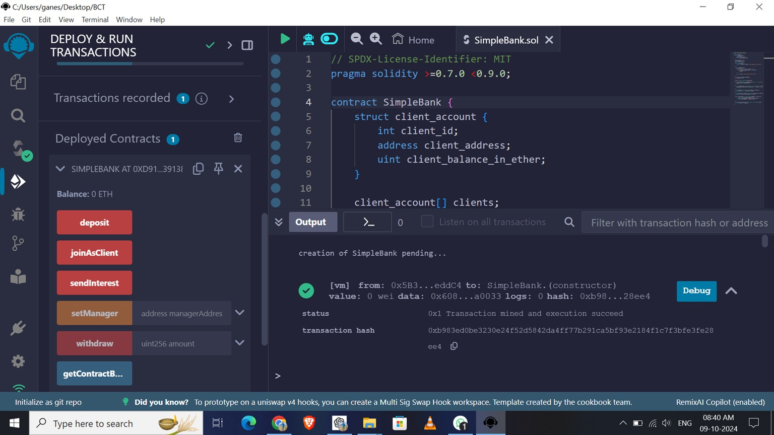

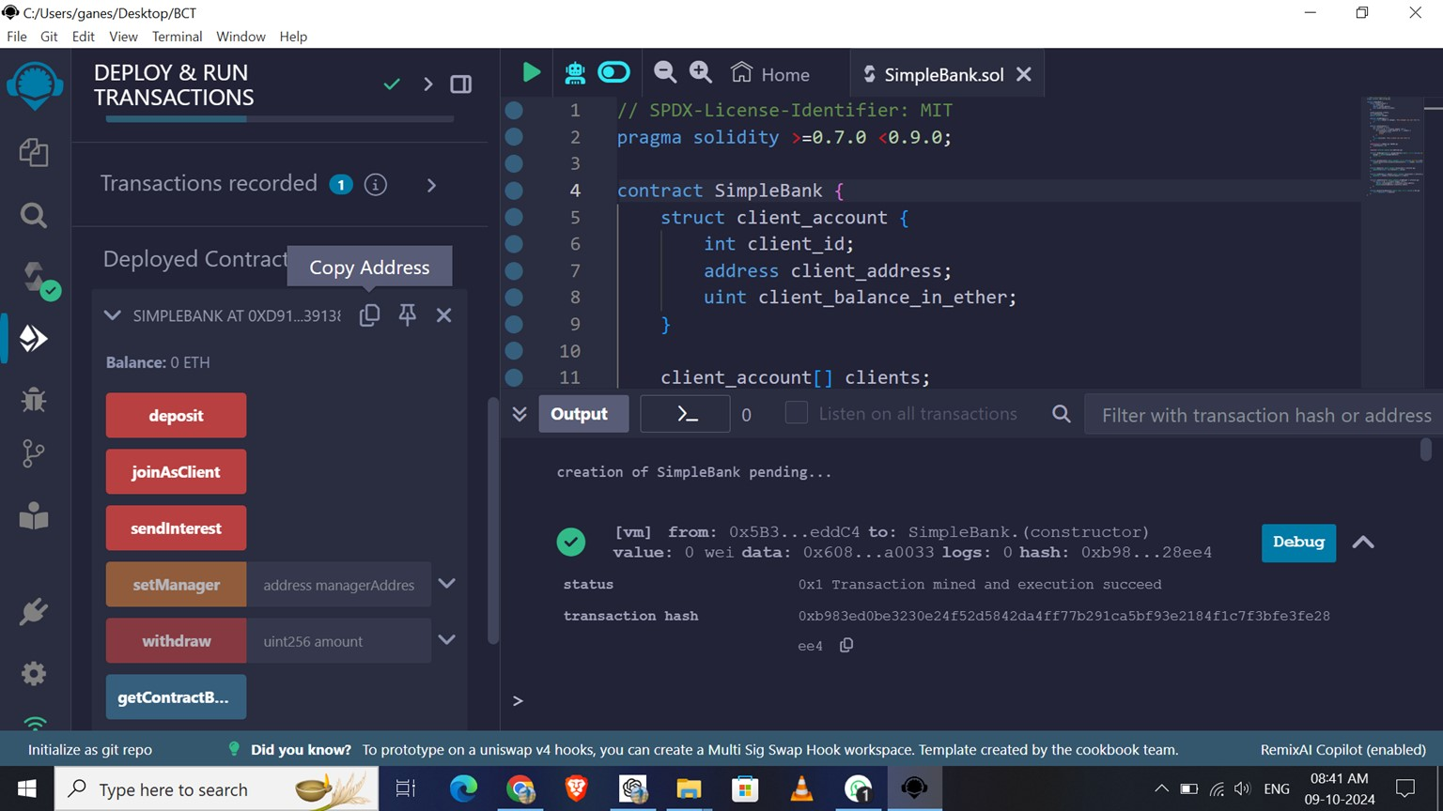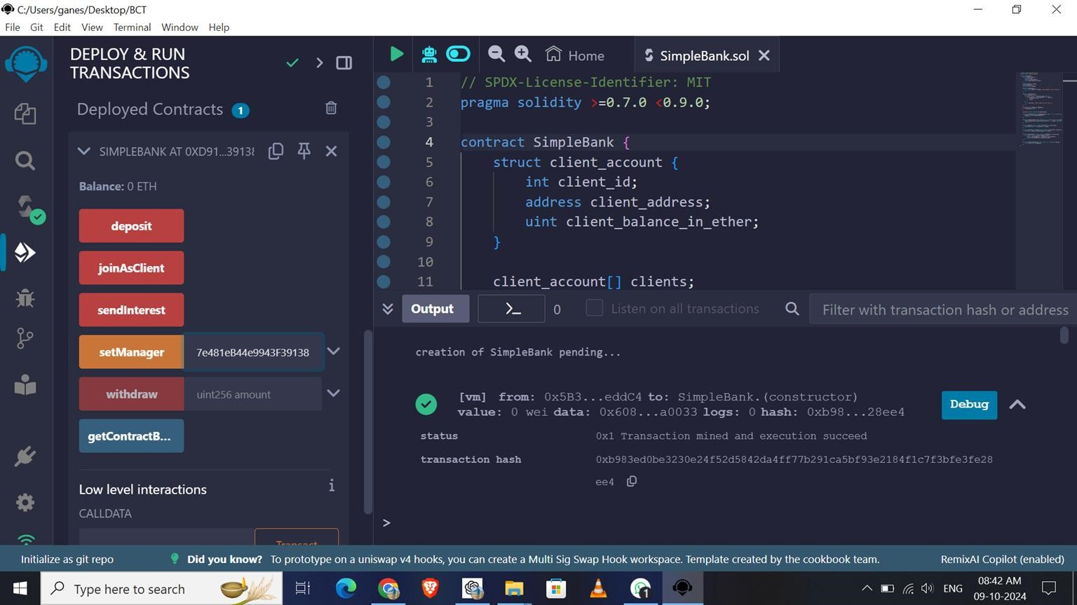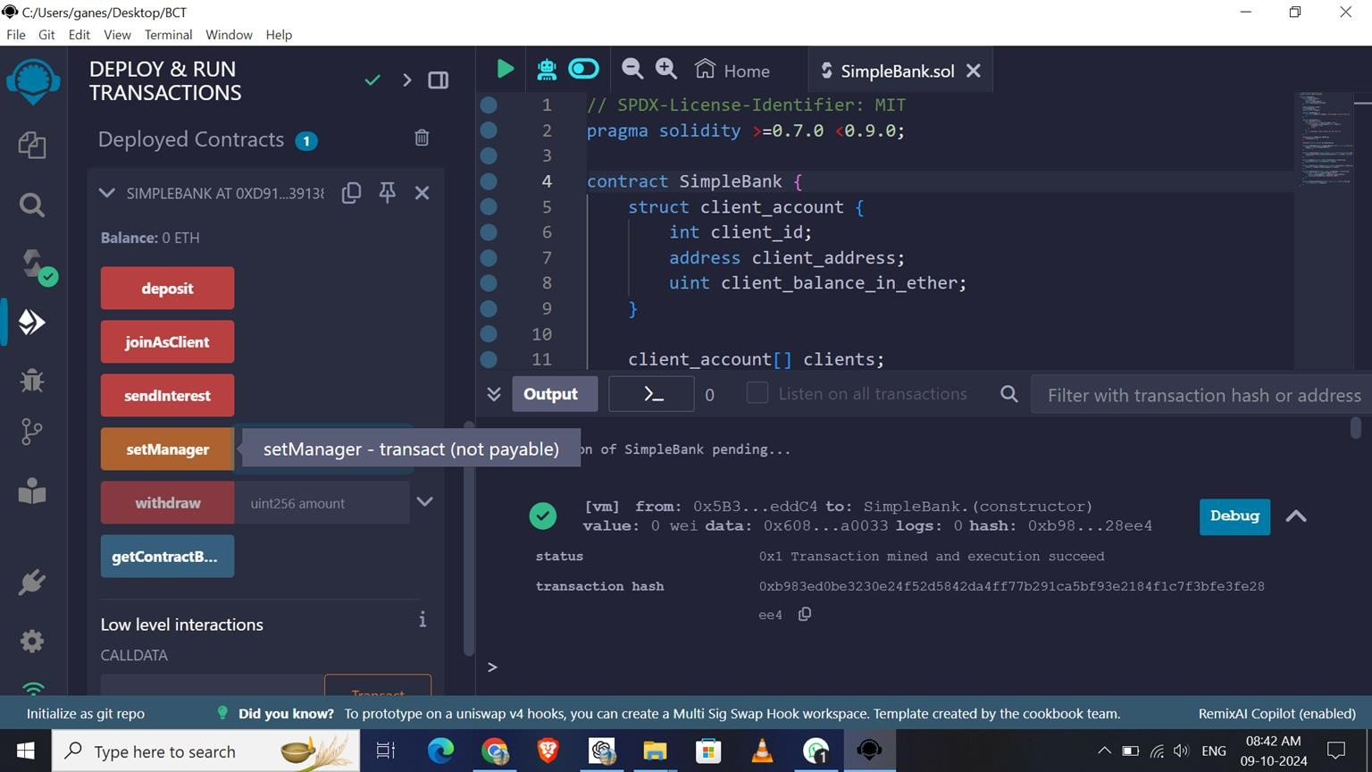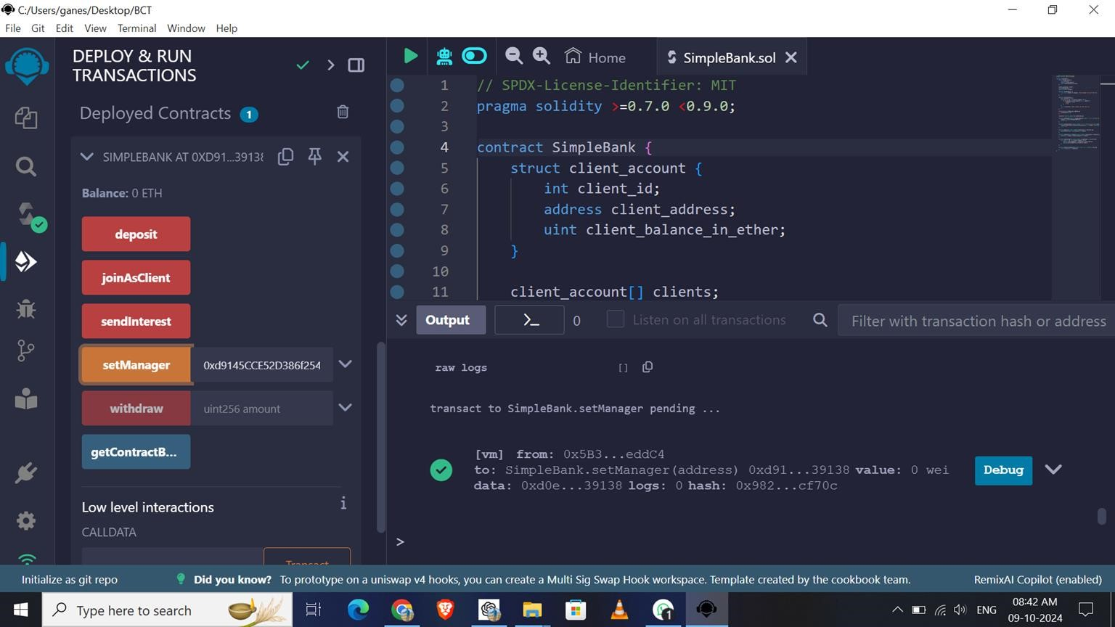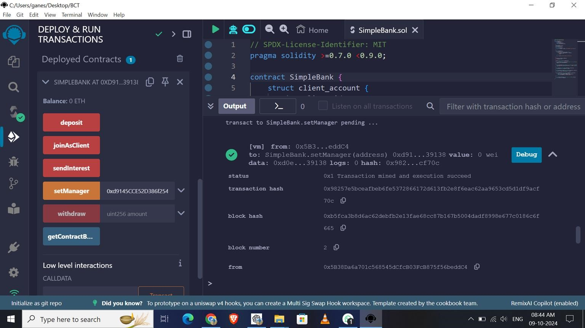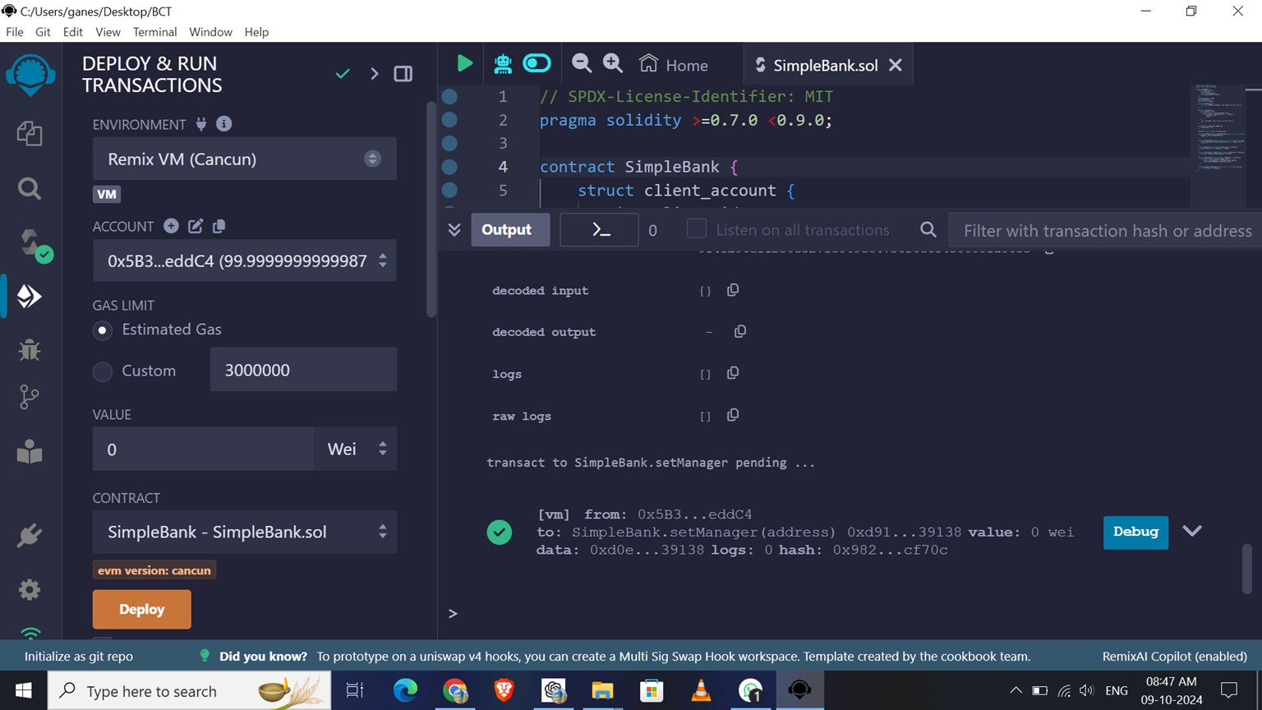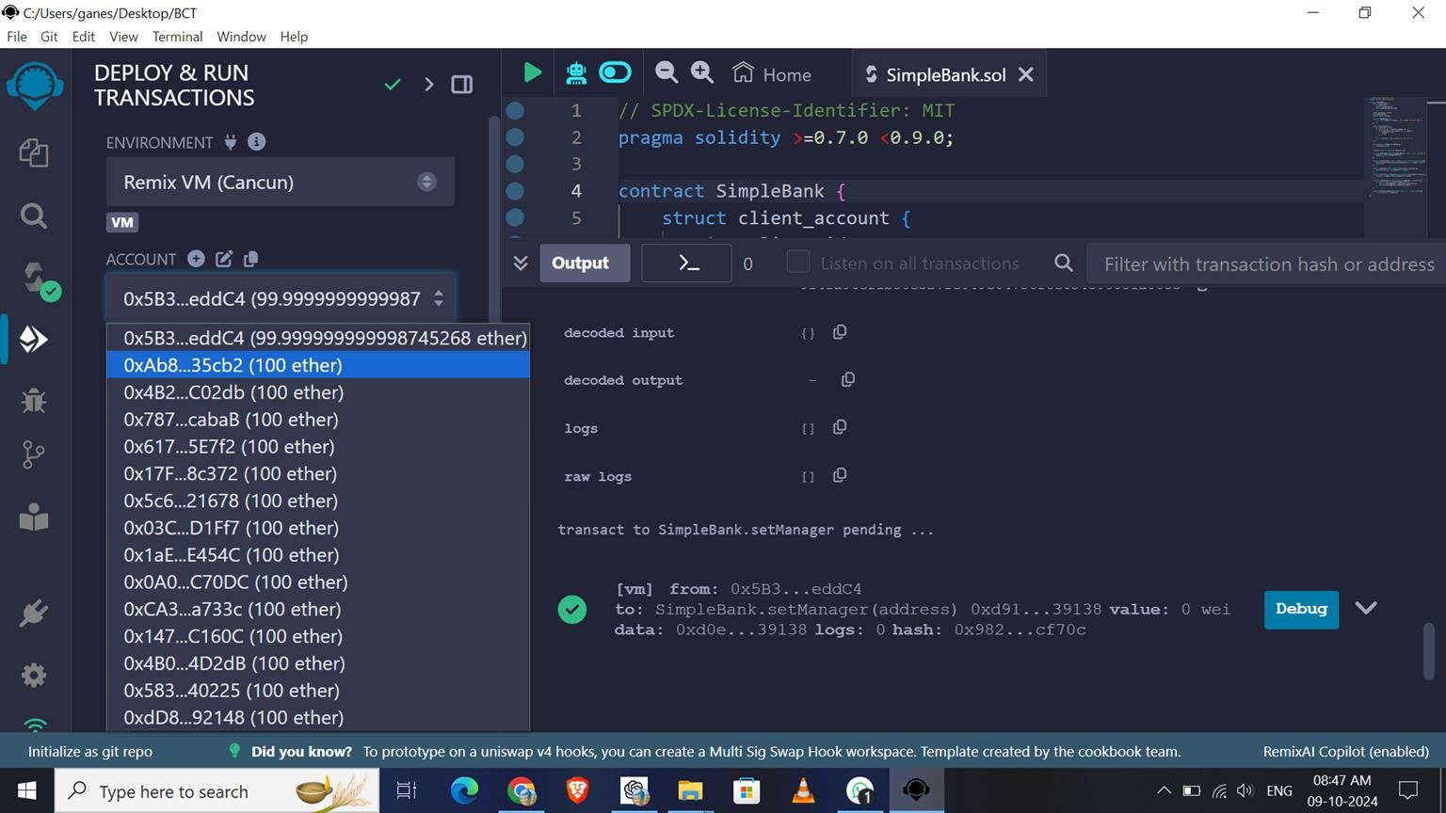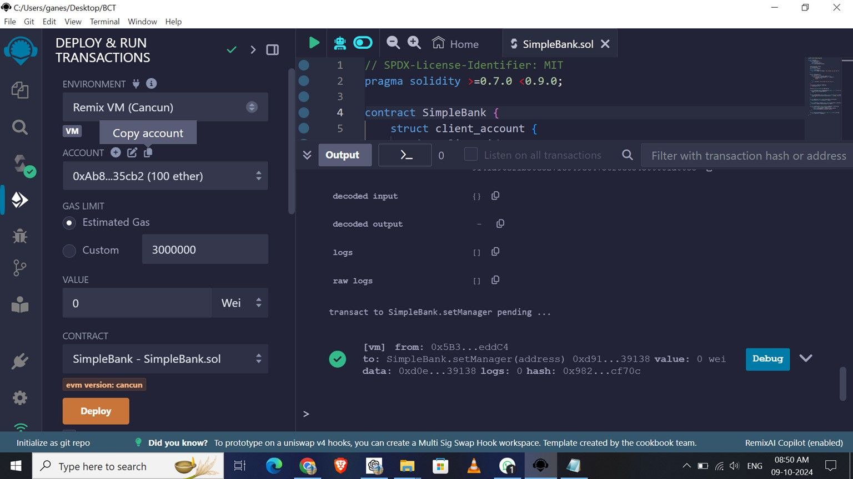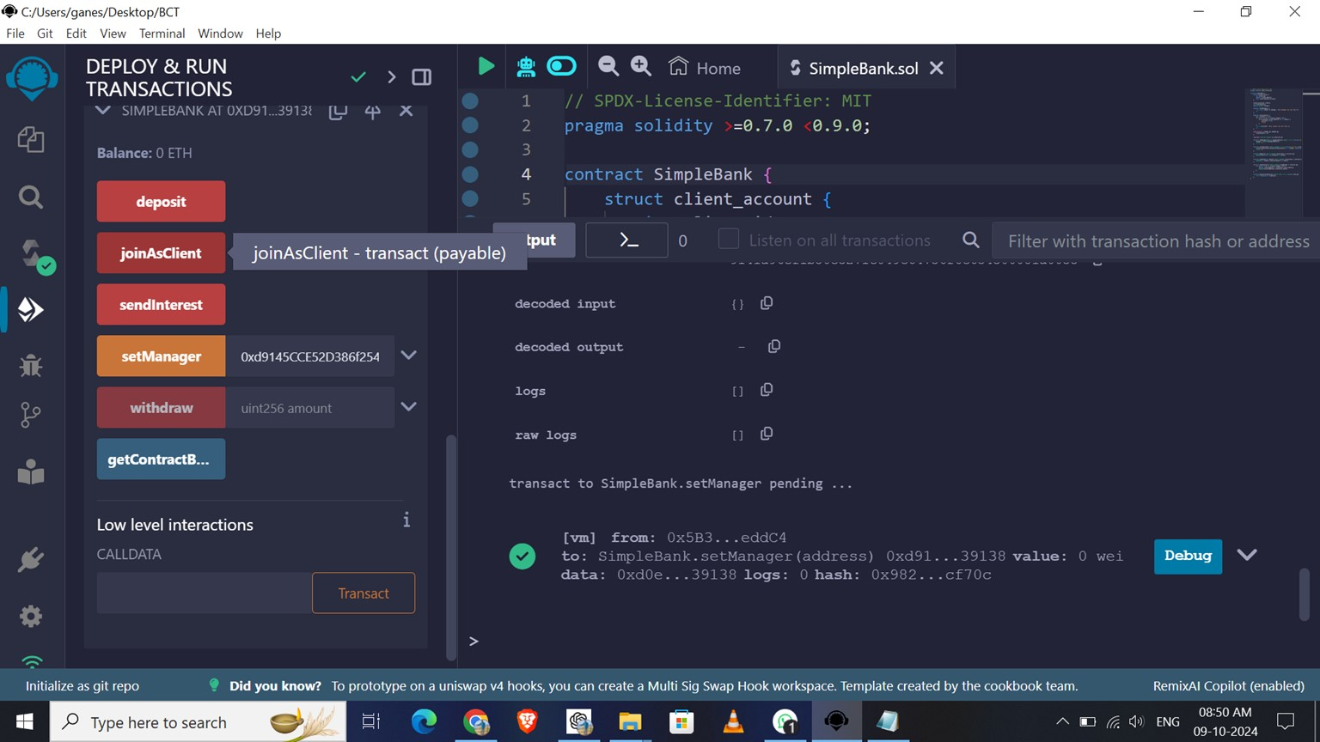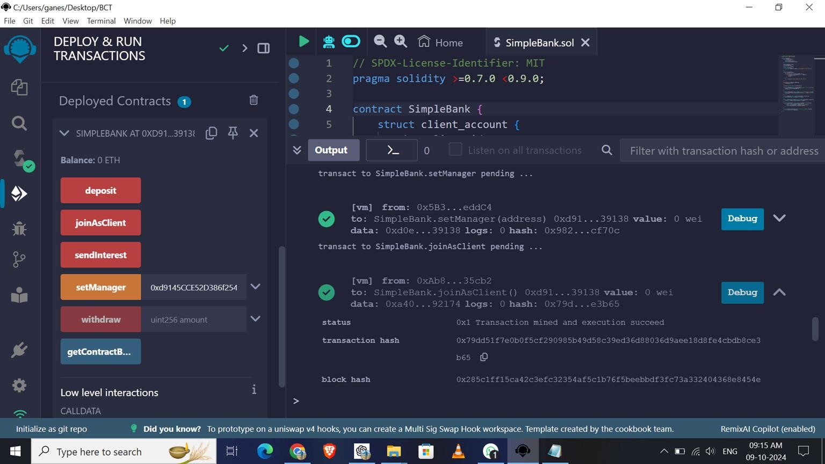

# To **Deposit** Ether

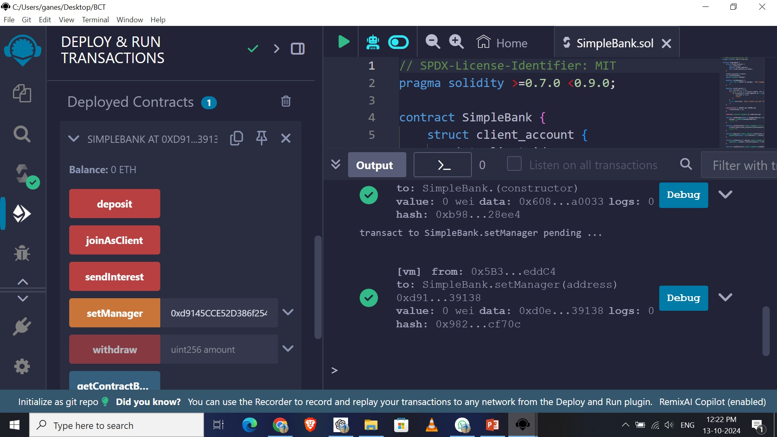

Now the balance is 0 ETH

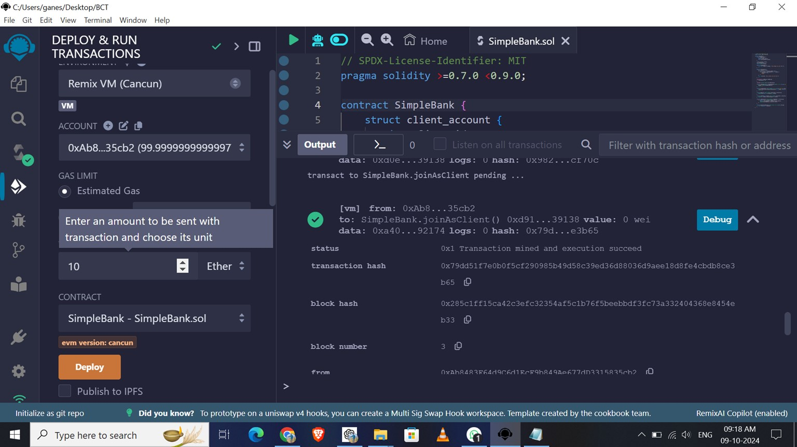

Enter Value 10 and Select Unit ETH

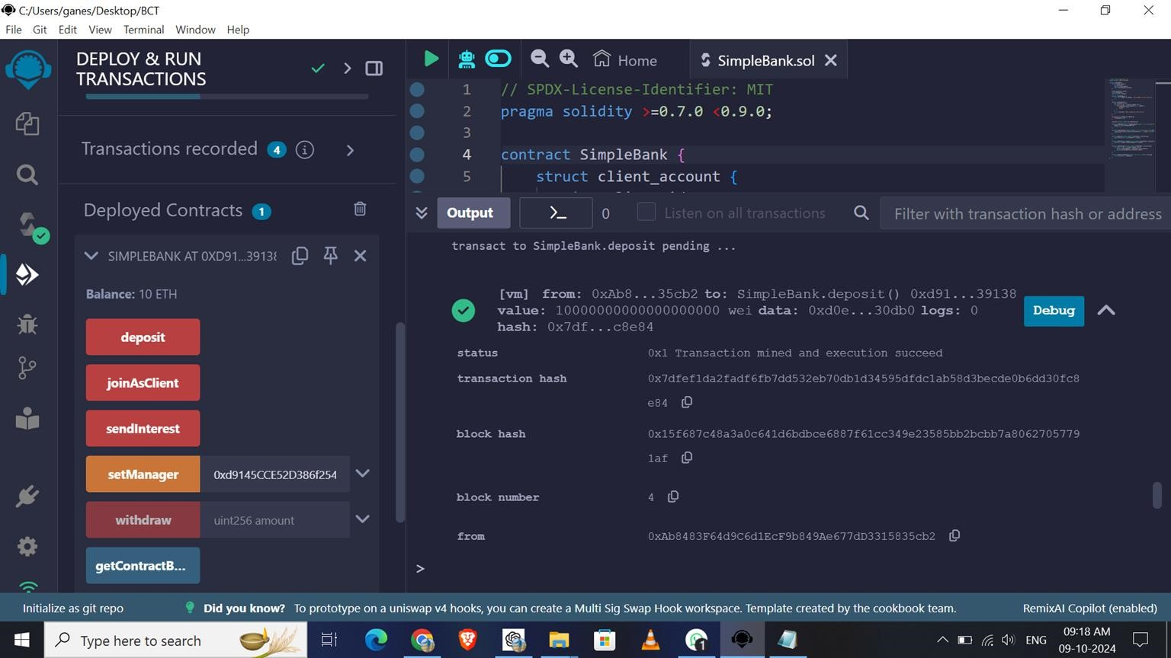

Now Check the Balance is 10 ETH

To **Withdraw** Ether

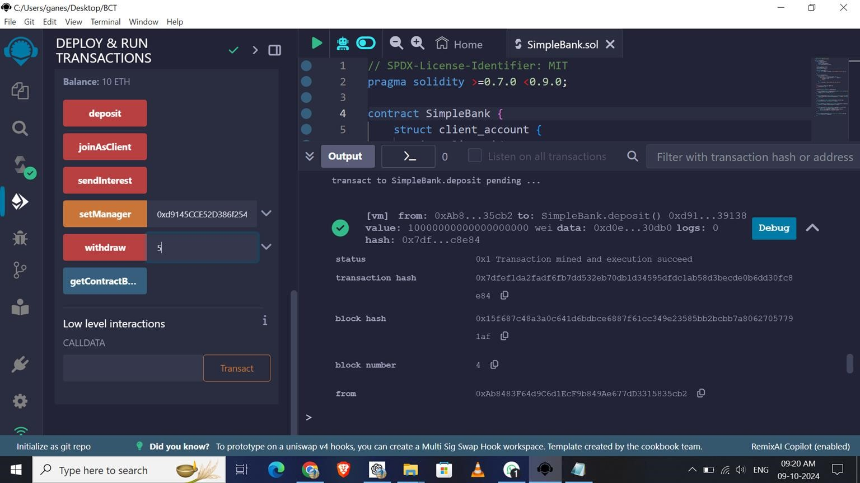

Enter the Amount of Ether to Withdraw out of 10



For Example: Enter 5 ETH

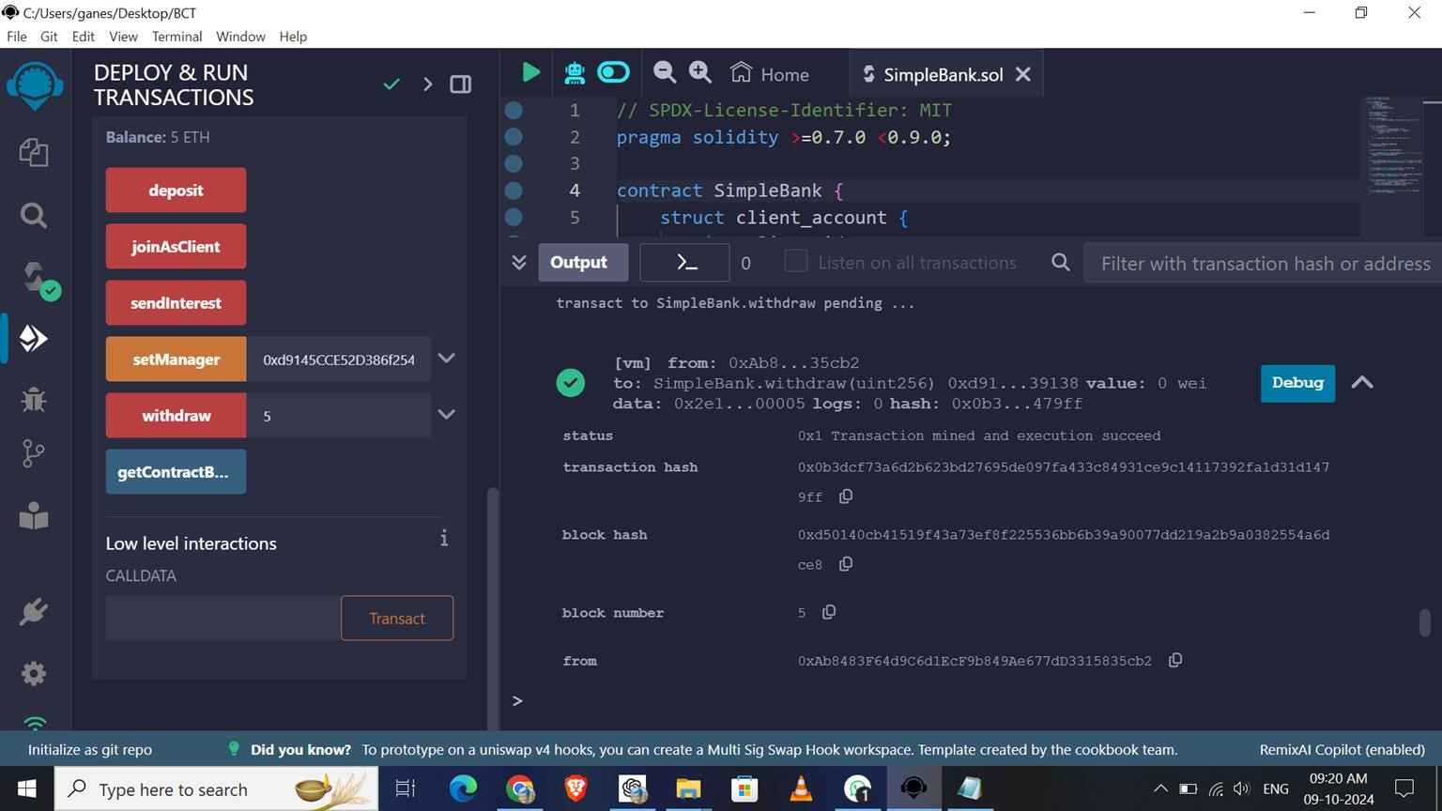

Cli

ck On Withdraw Button

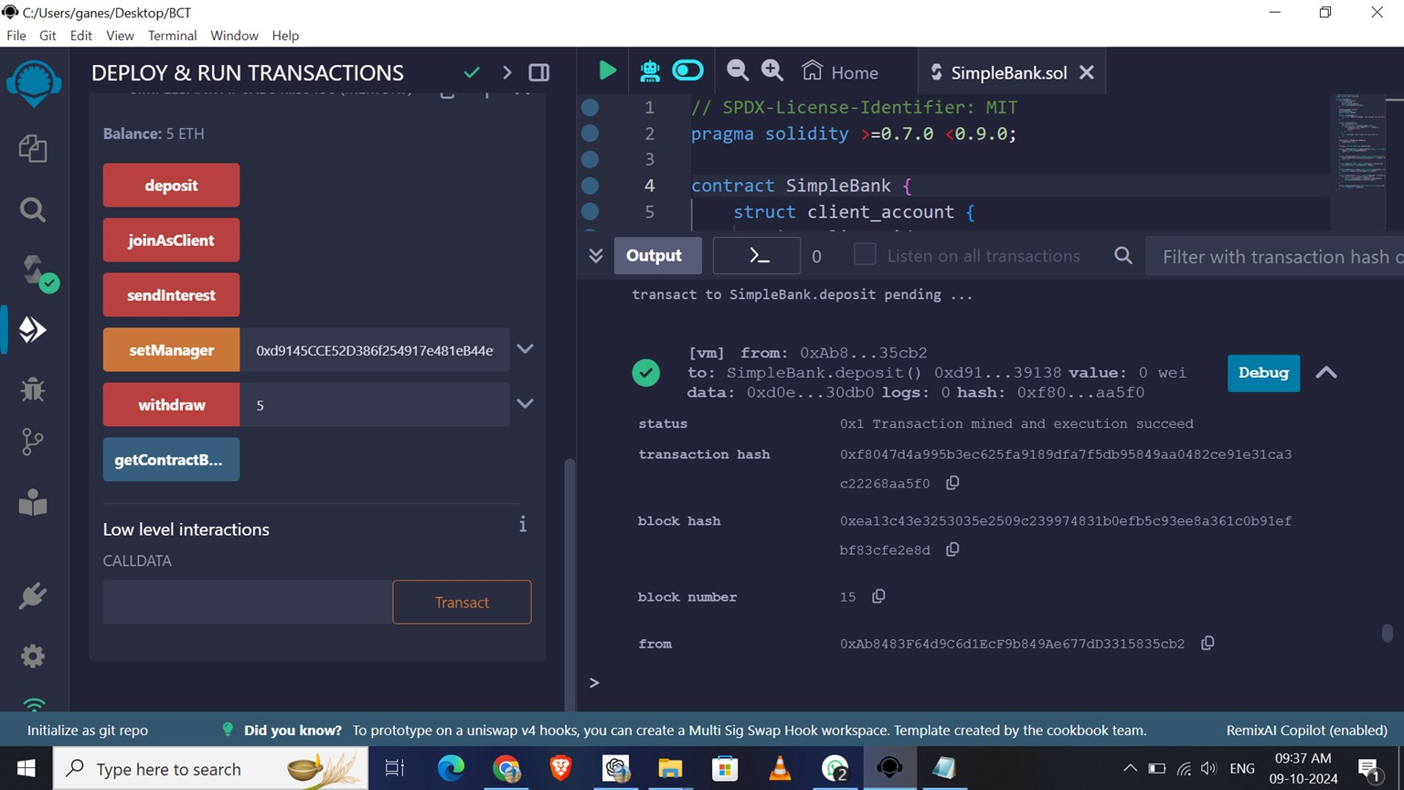

Now Check the Balance is 5 ETH Remaining

To **Show Balance**

